Course: JavaScript DA558A HT26
Lab 1: Remix Personal Portfolio
Development Documentation: Grade 5
Clementina Obasi

1. Design Journey
Prior to when I started to code, my idea was to design a simple but professional portfolio that could showcase my interests, education, projects as well as skills. I also wanted the website to be able to communicate that my interests lie in technical work, with emphasis on presentation of information clearly, since my background is embedded in cybersecurity and technology.
However, I did not want to overload or complicate the portfolio, especially with visuals effect because of my initial vision, which is demonstrated in cleanliness, organization as well as easy navigation. I wanted website visitors to be captivated by understanding who I am, and what am capable of accomplishing with little information search and organization
I considered dividing the information into different pages instead of having all the information on a single page, before I settled for the final structure I would work with. I realized having information on separate page would further make the content easier to organize, and also provide visitors with a very clear way to navigate between sections. Furthermore, I wanted inclusion of a gallery due to the fact that I though visual content would give that page its distinct personality, while making the portfolio more interesting.
I had sketched out a simple layout prior to the coding, using simple boxes to represent different sections namely: header, navigation, main content, images, and footer, for the pages as they come differently. The third page was inimitably assigned for projects, however, it was eventually changed to gallery, after the decision was to focus more on the page around photo gallery, instead of project list that is general. The initial design was not meant to be detailed, but serve as a placement holder for the different elements, before eventually writing the code, using HTML and CSS. The wireframe is given below

Navy/dark blue which is (#2c3e50) was chosen as the main colour in order to have a professional portfolio with calm appearance. Additionally, dark blue feels appropriate considering the fact that my portfolio is technology and cybersecurity oriented. It gives the impression of a more serious and technical environment.
Furthermore, the lighter blue which is (#3498db) was previously used as an accent colour to further create contrast, making more important elements stand out. This is because I did want everything to appear dark, the lighter blue colour gave a variation tot eh design.
When it came to the font, heading went with Georgia and main body text went with Arial, Georgia was chosen because of its distinct and professional appearance, while Arial looks simple and very easy to read.

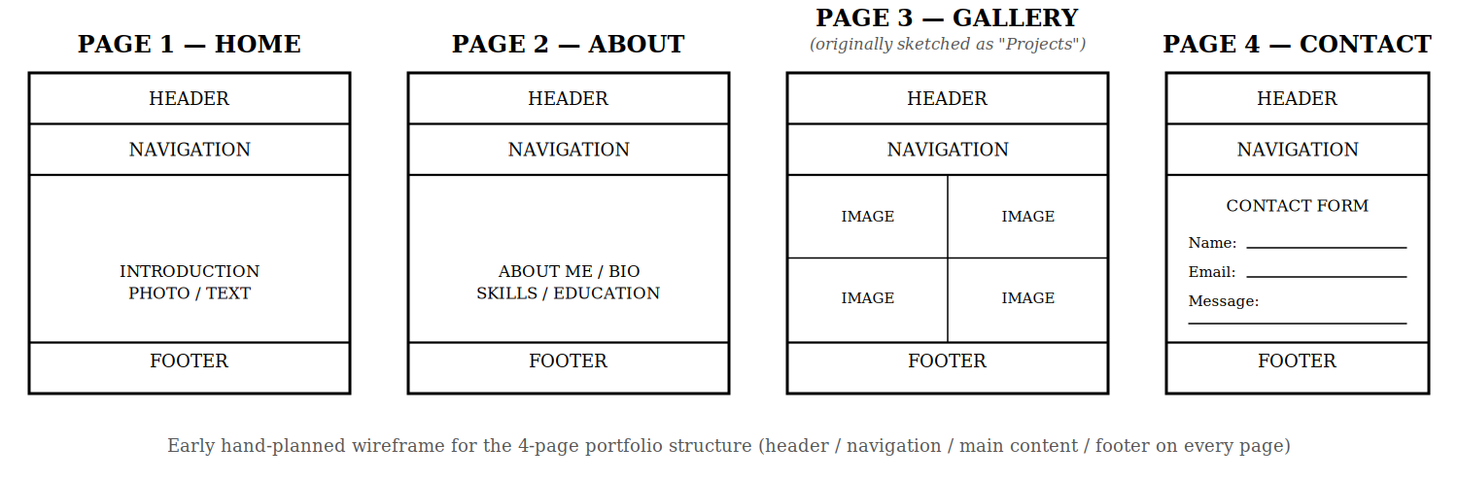
Overall, the aim was not to make the design flashy, but to make it appear calm and professional. The colours, fonts, and spacing have been specifically chosen so as to make the information readable, while giving the portfolio its identity.
However, the most visible difference between the first and final version was the basic appearance the first version had, which was mainly made up of plain black text and the HTML structure with no CSS styling. This worked for a webpage but made it look more of a document that portfolio that’s was finished.
The final version contains spacing, navigation styling, different font styles, responsive gallery, a proper color scheme, hover effects and styled footer. The layout was also improved so as to distinguish the different parts of the portfolio
The most notable improvement is the navigation, the earlier version as plain and had no proper visual structure. Navigation was styled in the final version, making it easier to identify and utilize. The footer was not left out, colour improvement made both appearance and accessibility easier.
The later version is considered better due to the fact that it’s more organized, visually appealing and easier to navigate. Additionally, the purpose of the portfolio was d by designed choices, making it feel more professional and personal, instead of just HTML content merged together.

The use of the assigned Seed Constraint by the lecturer
The seed color #D1495B which was given to me by my lecturer is used as an accent color on my website. You will be able to notice the difference when you hover over the four navigation links both at the top and at the footer. You can also notice differences in the other interactive or elements that are being highlighted. My reasoning for using the seed color as an accent instead of the main background is because I wanted the website to look more professional, clean, as well as to be able to read in an easy way. The darker colors such as the dark blue shows the main structure of the design, meanwhile #D1495B draws attention to interactive elements that are important without making the page feel colorful in an overly way. I also defined the color as a CSS variable, that is --color-accent, so that it can be used throughout the website in a consistent way, as well as changed easily in one place if needed.

2. Technical Explanation
Root variable was implemented so as to make changes from central point. Example is demonstrated in the primary colours that has been used, changing colours over different pages only required me to change the value in the root variable, which affects all pages, instead of having to search through the whole website to change the colour manually. This also make maintaining CSS easier, while consistency is maintained.
For semantic HTML, <header> for the top part of the page due to the introductory content like heading and title. It communicates where the header is. Additionally, <nav> was use for navigation links because it represents how users move in-between pages, because using <div> doesn’t give the content same semantic meaning. The <main> tag was used for the webpage’s main content, this separates content from structure, making it easier to understand.
When it comes to transition, an interval of 0.3 seconds was chosen because it’s fast enough not to slow down the user, though still noticeable. Ease was also used so the image doesn’t suddenly appear, the smooth transition makes the hover effect feel more natural. Other time intervals were tried, however, 0.3 appeared to be the most suitable.
3. Accessibility and Responsiveness
Apart from fixing the footer contrast, alt text was added to images in order for user that use screen reader to understand the images. Additionally, keyboard focus states was added to form fields and navigation link, so as to see which element has been selected. The <label> element was used for the forms so that each input is clear and represents that actual description.
In testing the website, chrome browser was used to open it, DevTools to test different screen sizes. Device toolbar was used to check how the website looks on mobile, and tablet sizes, to see if the content actually fits into the screen, whether forms and images can be seen, and whether navigation worked properly. After this, keyboard testing was done using only keyboard keys such as pressing tab key to move through navigation. This came out positive, focus could be seen and it move in a logical order.
However, I found one issue with the footer, text did not have enough contrast against the background which made it difficult for some readers to read. This was fixed by changing footer colours for better text contrast with the background. Upon implementing the change, text was checked again make sure it can be read, further improving website accessibility without changing the overall design

4. Problem-Solving Record
Problem 1 – Live Servicer Confusion
The first problem I encountered was how to find Live Server extension in VS Code. Though I had installed it from the extension, it still became confusing because I closed the Live Server tab. I eventually learnt that stopping the server or closing the tab does not uninstall the extension, but stays uninstalled and can be open again by opening HTML file, using the "Open with Live Server"
Problem 2 – Footer Contrast Bug
The text in the footer was pretty difficult to read due to the fact that there is not enough contrast between background and text. I further checked the CSS style for footer in order to understand which controlled the text and background, so as to identify the exact problem. This was eventually solved by creating a stronger contrasts, while I kept the design consistent with the rest of the website. With this changes made, I then proceeded to confirm the text was now easier to see, this further made me more aware that design can be good looking but have problem of accessibility.
Problem 3 – Image File Names Not Matching
Making sure image names and actual images file in the project folder matched was another problem I faced. An example is having a path of HTML had src="images/photo1.jpg", but the actual file had either another name or extension. This made some images not to appear. This was solved by making sure all image file in project folder matched with those in the path in the HTML, all images displayed clearly.
In all, these problem have taught me to have a troubleshooting oriented and should be patient in understanding codes so as to know where the best position to implement them is.
5. Personal Reflection
I would say my portfolio actually represents me due to the fact that it indicates my interests and also displays my professionalism and what has been learnt. My intention was for the website to have a professional look, however, I also wanted something that could be easily created by me. This is because the portfolio is a representation of my interest, projects, skills and background, even though it is not perfect. It also shows I can learn skills and also apply it to practical project.
The responsive gallery is my proudest design and technical skills due to the fact that seeing layout of a website change depending on the screen size can be amazing to watch and see. My initial mindset was to see how website will look on my laptop, however, I quickly learnt that considerations has to be given to people will access the website using mobile phones and tablets. They key lies in the implementation of CSS Grid and responsive rule. Additionally, was proud I was also able to add hover effect and transition, this made the website feel more interactive while the design remained simple.
The lab session helped me understand semantic HTML more, prior to this, I only saw HTML elements as ways to make content appear on a webpage. However, these elements do more than just making content appear, they also communicates the purpose of the content. A typical example is demonstrated in the <header>, <nav>, <main>, <section>, and <footer>, a combination of these gives a website a clearer structure, instead of using <div> all through. Now, I understand in-depth how semantic HTML can support accessibility
My understanding of CSS has greatly improved after learning that it is not only about choice of colours, but can also make layout responds to different screen sizes and orientation, layouts and transitions, as well as spacing. All these contributes to the way a website looks, appears, responds and feels.
Overall, the lab session has added more confidence to me, especially when it comes to building a website from scratch. Though is still have more to learn, understanding the relationship between HTML structure, CSS styling, responsiveness, and accessibility, has increased my knowledge about website design and development. Additionally, it has widen my scope and now made me appreciate website more.

